READING PET 8 TEST 1

**Part 1: THÌ HIỆN TẠI ĐƠN (THE SIMPLE PRESENT) (xem link)**

**\* Choose the best option:**

1. Police ……….. robbers.

A. catch B. catches C. caught D. have caught

2. My dad is a driver. He always ……….. a white coat.

A. wear B. wears C. wore D. have worn

3. They never ……….. beer.

A. drink B. drank C. drunk D. have drunk

4. Lucy ……….. window-shopping seven times a month.

A. go B. goes C. went D. has gone

5. She ……….. a pen.

A. have B. has C. had D. has had

6. Mary and Marcus …… everyday.

A. eat out B. eats out C. ate D. have eaten

7. Mark usually …… TV before going to bed.

A. watch B. watches C. watched D. has watched

8. Maria is a teacher. She …… students.

A. teach B. teaches C. taught D. has taught

9. Max, Frank and Steve …… in the yard.

A. don’t skate B. doesn’t skate C. no skate D. not skate

10. The boy …… stones.

A. don’t throw B. doesn’t throw C. threw D. did not throw

**Key.**

1. Police **catch** robbers. (A)

2. My dad is a driver. He always **wears** a white coat. (B)

3. They never **drink** beer. (A)

4. Lucy **goes** window-shopping seven times a month. (B)

5. She **has** a pen. (B)

6. Mary and Marcus **eat out** everyday. (A)

7. Mark usually **watches** TV before going to bed. (B)

8. Maria is a teacher. She **teaches** students. (B)

9. Max, Frank and Steve **don’t skate** in the yard. (A)

10. The boy **doesn’t throw** stones. (B)

**Part 2** READING PET 8 TEST 1

**Questions 1-5**

Look at the text in each question. What does it say? Mark the correct letter **A, B** or **C** on your answer sheet.

Example:

|  |  |  |
| --- | --- | --- |
| A. The six - week course is cheaper if you also do the one-day class.= discount: giảm giá  B. The one- day class is free for those who book the six-week course.  C. You must pay for the six-week course before you do the one- day class.  Answers: A |  | |
| 1. **If Sally wants to go on the holiday she must**  A. send the details that were requested.  B. contact the travel agency for further information.  C. pay a deposit this evening.  (pay a deposit: nộp tiền đặt cọc= Booking: Đặt trước) |  | |
| 2.  A. Even if the garage is closed Peter can pick up his car. (spare key: chìa khóa xơ cua, dự phòng)  B. Peter should reach the garage before 5.30 in order to collect his car.  C. Peter cannot get his car until he collects the key. | |  |
| 3.  A. If you lose your bus ticket, you should inform a transport officer.  B. There could be ticket checks during your bus journey. (request to see it anytime: yêu cầu xem/ soát vé bất cứ lúc nào)  C. Passengers without a ticket may request one from a transport office. | |  |
| 4. **Jen says that**  A. Lewis didn’t know that Paula was away until tomorrow.  B. Lewis doesn’t mind what time Paula calls him at home. (give a ring= call, didn’t matter= didn’t mind)  C. Lewis won’t call Paula until late this evening. | |  |
| 5. **From 15 September museum visitors**  A. will have to join a group. (guided tour only )  B. will be free to go round alone.  C. will have to pay for a tour guide. | |  |

**Part 3**

**Questions 21-25**

Read the text and questions below.

For each question, mark the correct letter A, B, C or D on your answer sheet.

|  |
| --- |
| **Cliff Jones**  Image result for cliff jones"In 2005, Cliff Jones began a journey round Britain on a unicycle, a bike with only one wheel. He had already made a documentary film about his experiences travelling round Europe in a 50-year-old car. He was mad about motor sport and had a job building racing car engines. To save money, Cliff rode to work in London on an old bicycle, which he also used to go to France on holiday. ‘That trip opened my eyes,' he says. ‘I decided to do a tour of Britain by bike.’  Cliff didn’t want a normal touring bike, and he knew he wanted to build one himself. ‘The craziest bicycle I could think of was a unicycle, so I went to a factory to see how they are made.’ After one false start in 2004, when he had to tum back because of a knee injury, he finally set out in 2005. He was away for four months, and travelled over 8,500 km.  The best bit of the trip was arriving in Wales and seeing Mount Snowdon. 'Although I met cyclists who could easily ride up mountains on their bikes, which I couldn’t do, I never regretted my unicycle. The further away from London I got, the more amazed people seemed by it. His worst moment came when he had to drink some dirty water from a stream. A serious fever kept him in bed in hospital for five long days. He was determined not to give up and go back home before he had completed his challenge, but found it hard to carry on because he felt so weak. Yet despite all this, Cliff now says, 'If I could afford it, I would like to do something similar again.’ |

21. What is the writer trying to do in this text?

A. advise people to take adventure holidays

B. explain a rather unusual choice of transport (Cliff Jones began a journey round Britain on a unicycle, a bike with only one wheel. He had already made a documentary film about his experiences travelling round Europe in a 50-year-old car.)

C. suggest the benefits of a special vehicle

D. persuade people to travel long distances

22. What made Cliff realise he wanted to cycle round Britain?

A. touring Europe in an old car

B. visiting a unicycle factory

C. attending motor races abroad

D. taking his bike to another country (To save money, Cliff rode to work in London on an old bicycle, which he also used to go to France on holiday. ‘That trip opened my eyes,' he says. ‘I decided to do a tour of Britain by bike.’)

23. When Cliff met other cyclists in the mountains, he was

A. anxious to get away from them.

B. satisfied with his own type of bicycle. (I met cyclists who could easily ride up mountains on their bikes, which I couldn’t do, I never regretted my unicycle.)

C. jealous of what they were able to do.

D. surprised by their attitude towards him.

24. What was Cliff's biggest problem during the trip?

A. He fell ill for nearly a week. (A serious fever kept him in bed in hospital for five long days.)

B. He had to go home to rest.

C. He wanted to finish his trip early.

D. He took too long to get to one place.

25. What might Cliff say after his trip?

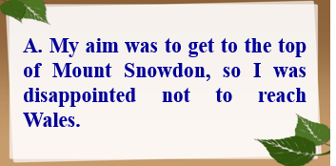 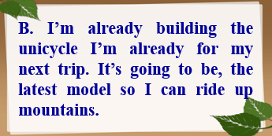

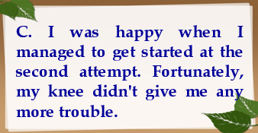 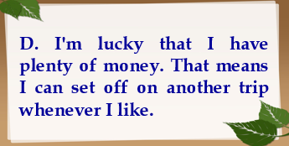

Key:

C. I was happy when I managed to get started at the second attempt. Fortunately, my knee didn't give me any more trouble.

(After one false start in 2004, when he had to tum back because of a knee injury, he finally set out in 2005.)

**Part 4**

**Questions 26-35**

Read the text below and choose the correct word for each space.

For each question, mark the correct letter A, B, C or D on your answer sheet.

Example:

0 A. brought B. held C. kept D. grown

Answer: A

|  |
| --- |
| Image result for Alpacas"**Alpacas**  Alpacas were first (0) ............ by the Inca people in the mountains of South America, more than six thousand years ago. These animals (**26**) ............ clothes, food and fuel for their owners. The softest wool was (**27**) ............ worn by the leaders of Incan society though.  When Spanish explorers (**28**) ............ in the fifteenth century, sheep were introduced and these gradually (**29**) ...... alpacas in the region. It wasn’t (**30**) ...... the middle of the 20th century that both farmers and fashion designers began to recognise the (**31**) ......... of alpacas again. They are easy to look (**32**) ......... since they eat grass and are used to low temperatures. Their wool, which comes in a (**33**) .......... of natural colours from white to dark brown, is lighter and warmer than sheep's wool and (**34**) .......... strong. It is not surprising (**35**) .......... that alpacas are becoming a familiar sight in the fields of North America, Australia and the UK. |

26. A. supported B. provided C. turned D. gained

27. A. mainly B. fully C. extremely D. absolutely

28. A. reached B. delivered C. arrived D. transferred

29. A. retired B. removed C. returned D. replaced

30. A. until B. after C. during D. before

31. A. prizes B. rewards C. qualities D. points

32. A. at B. after C. for D. like

33. A. row B. group C. range D. crowd

34. A. only B. also C. instead D. too

35 A. therefore B. already C. otherwise D. enough